**PRDA – 03 HR Analytics**

Task:

1. Get data from the database with the given credentials.
2. Create 3 KPI’s that list the number of employees, percent of workers working remotely and in HQ and the average age.
3. Create a Line chart showing the hiring rate By Year.
4. Create a Donut chart representing the gender of employees.
5. Create 3 Bar charts showing employees By State, By Department & By Race.
6. Analyze all the features and derive multiple insights.
7. Visualize the data using Tableau /PowerBI and derive insights and give your inputs/suggestions to the company.

About Dataset:

HR Analytics can provide valuable insights and benefits to organizations in many different areas, from talent acquisition and retention to workforce planning and diversity and inclusion. By leveraging HR Analytics, companies can gain a competitive advantage by developing data-driven strategies that help them attract and retain top talent, improve employee engagement and performance, and foster a positive and inclusive workplace culture.

This particular dataset holds 13 columns and 22,214 records. The 13 columns has information like their name, birth date, race, what department they work at, their job title, remote/HQ, hire date, term date, city and state.

Database Credentials:

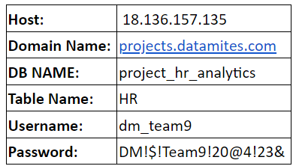

Attribute Information:

**id:** An identification number for each employee.

**first_name:** The first name of the employee.

**last_name:** The last name of the employee.

**birthdate:** The date of birth of the employee.

**Age:** Age of the employee, calculated based on the birthdate.

**race:** The race of the employee.

**department:** The department in which the employee works.

**jobtitle:** The job title of the employee.

**location:** The location of the employee's office or WFH.

**hire_date:** The date on which the employee was hired.

**termdate:** The date on which the employee left the company, if applicable.

**location_city:** The city where the employee's office is located.

**location_state:** The state where the employee's office or work site is located.

You can provide your inputs/solution as a PPT presentation and you can explain your project, record it and send it with the PPT file.